Wireless Lock SDK System Design Specification
Author | Revision Number | Date
kurtrips | 1.0 | August 17, 2011

Wireless Lock SDK System Design Specification 1
System Design Specification 3
1. Introduction 3
1.1 Purpose 3
1.2 Glossary 3
2. Logical Architecture 4
2.1 User Interface 5
2.2 Data Access 5
3. Modular Architecture 5
3.1 Wireless Lock SDK WavePro - Custom Component 5
3.2 Wireless Lock SDK ORP - Custom Component 5
3.3 Wireless Lock SDK Assembly 5
4. Data Model 5
5. Process Architecture 5
5.1 Logging 5
5.2 Exception Handling 5
5.3 Configuration 6
5.4 Thread Safety 6
6. Security 6
6.1 Authentication and Authorization 6
SSL will be used to encrypt the traffic to and from the client and server of either protocol. The following certificates will be required: 6
6.2 Audit 6
6.3 Data Integrity 6
6.4 Data Migration 6
7. Deployment and Development Concerns 6
7.1 Physical Deployment 6
7.1.1 Metrics Requirements 6
7.1.2 Performance Requirements 6
• The maximum expected number of concurrent users is one. 6
• For the SDK application detailed in the questionnaire there will be only one user using at any given time. 6
7.1.3 Software 6
7.1.4 Operating System 6
7.1.5 Database 7
7.1.6 Unit Testing 7
7.1.7 Source control 7
7.2 User Interface Implementation 7
7.2.1 Prototype conversion 7
7.2.2 Resolution 7
7.3 Future Enhancements 7

System Design Specification

Introduction

Purpose
The purpose of this project is to implement an SDK for a locking system designed to secure a variety of doors in different applications from office buildings to commercial stores and government offices. The locking system consists of host software, a number of locks, a portable programmer and a wireless gateway (required for the wireless locks option). Depending on customer requirements and budget constraints the system can be used in an offline mode or a wireless mode with a quasi real-time data connection back to the host software.

The locking system has an open architecture program that is designed to provide information and sample code to third party customers that want to interface their applications to control and interact with said locking system (thus their software becomes the host software). The program is governed by 3 existing interface control documents that define the protocols used to communicate to each device.

This project focuses on creating an SDK to enable a third party to communicate to the locking system via the WAP from a software based application (the host software).

The lock system as defined currently works by sending commands from host software down to a lock via the ORP protocol. The communication packets/commands are routed as follows:
Host Software (LMS) ---> Wireless Access Point --> Lock Radio (WLM) ---> Lock
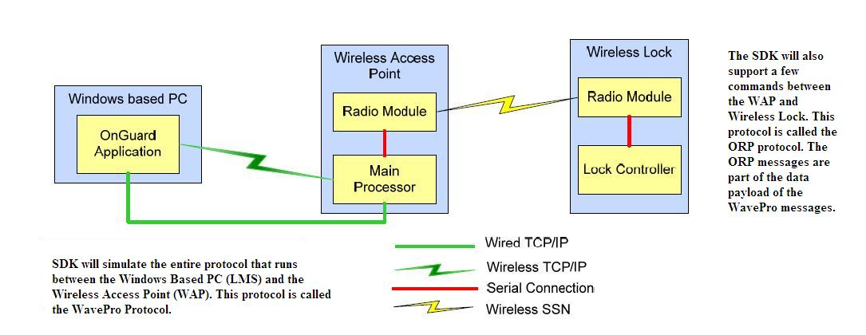

Glossary
Acronym/Term | Description
TCP | Transmission Control Protocol
IP | Internet Protocol
WAP | Wireless Access Point
WLM | Wireless Lock Module
LMS | Lock Management System
SSL | Secured Socket Layer
SSN | Secure Sensor Network (Proprietary wireless network of client)

Logical Architecture

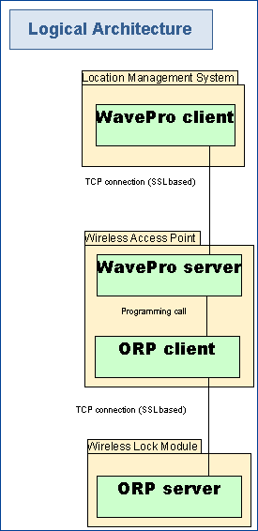

On a logical level, the SDK is composed of four main components:
- WavePro client – The main access point of the client. This usually resides on the LMS
- WavePro server - The server for the WavePro protocol. This usually resides on the WAP.
- ORP client - The client for the ORP protocol. This usually resides on the WAP.
- ORP server - The server for the ORP protocol. This usually resides on the WLM.

The WavePro client talks to the WavePro server over TCP network.
The WavePro server talks to the ORP client directly using local programming language calls.
The ORP client talks to the ORP server over TCP network (for the purpose of this project). In reality, ORP client talks to ORP server over SSN connection.

User Interface
None

Data Access
None

Modular Architecture
The application will consist of 3 independent modules to be implemented in parallel. The modules will not be standard module architectures but instead will consist of 2 design components and one assembly.

Wireless Lock SDK WavePro - Custom Component
This design will be responsible for building the WavePro client and server.

Wireless Lock SDK ORP - Custom Component
This design will be responsible for building the ORP client and server.

Wireless Lock SDK Assembly
This assembly will be responsible for integrating the 2 design components. It will also be responsible for enabling the SSL protocol for the SDK. It will also be responsible for end-to-end testing of the SDK.

Data Model
There is no persistence model as such.
Entities are however provided for modeling the WavePro and ORP messages.
The WaveProRequestMessage and WaveProResponseMessage model a WavePro request and response. The WaveProMessageBody is an abstract class which models the payload of the Wavepro request.
The ORPMessage is the base class which models both the ORP request and response. The classes deriving from ORPMessage model the request and response for ORP commands and also the ACK and NACK messages used in this protocol.

Process Architecture
The following sections include the cross cutting functionality:

Logging
- The system will log all the errors, exceptions, warning and debug information during the application execution (together with date/timestamps of occurred problems’ moments).
- It is needed for further maintenance, support and improvement of the application.
- Log4net will be used for logging.

Exception Handling
- For unexpected exceptions in the WavePro client and server, the WaveProException class will act as base class. It will extend from .NET’s ApplicationException class.
- For unexpected exceptions in the ORP client and server, the ORPException class will act as base class. It will extend from .NET’s ApplicationException class.
- For known error conditions in the WavePro protocol, the WaveProResponseHeader.Result field will be used to signal error conditions. See section 4.5.1.10 RESPONSE Header Block: Result of ICD_WavePro_OA.pdf for more details.
- For known error conditions in the ORP protocol, the ErrorCode and EventId fields of the ORPResponseNack class will be used to signal error conditions. See section 5.1 and 5.2 of ORP_OA.pdf for more details.

Configuration
.NET’s Configuration API will be used for configuration. All configuration will be saved and read from the app.config file

Thread Safety
Client and Server classes of both protocols must be implemented as thread-safe. This is because we cannot assume the threading scenarios in which these classes will be used.

SSL over TCP
The TCP connection data will be encrypted with the help of SSL. The designer must design the TCP clients and servers with the help of SSLStream class. The design should be such that the location of the X509Certificate is configurable.

Endian-ness
The WavePro protocol requires the data to be in big-endian order. The ORP protocol requires the data to be in little-endian order.
The converter classes should handle the conversion from the underlying architecture to correct endian. The BitConverter.IsLittleEndian method will tell whether the underlying architecture is little endian or not. If the endian for machine is same as that of protocol, then the converter will not convert byte array to correct endian, otherwise the converter will perform the endian conversion.
See the EndianBitConverter and deriving classes in this library to see how to perform conversions from one endian to another.

Requirement mapping

Use Case | Requirement explanation
Access documentation | The Final assembly will be responsible for generating the help files from the source code documentation. See Final Assembly 1.1.5
Access reference implementations | The Final assembly will be responsible for providing reference implementations. See Final Assembly 1.1.4
Use sdk [external] | External
Install lock [external] | External
Create request data packet  Create response data packet | Data objects for request and response packets are provided in styx.wireless.lock.wavepro.entities and styx.wireless.lock.orp.entities namespace
Accept incoming request  Send outgoing request | The ORP and WavePro client and server classes take care of these use cases
Read encrypted information  Write encrypted information | These are covered in the assembly in which the 'SSL enabling' is a requirement. When SSL is enabled, the SSL protocol automatically takes care of the encrypting and decrypting information during read-write.
Open door  Change mode  Get battery level  Read lock information  Add/update users  Remove users | These are covered in section 1.2.3 of Wireless Lock SDK ORP 1.0 C# Custom Component
Emulate WAP device | The Final assembly will be responsible for providing emulator. See Final Assembly 1.1.6
Read locking plan data | The Final assembly will be responsible for reading locking plan data. See Final Assembly 1.1.3
Logging | Logging will be provided by both components.

Security

Authentication and Authorization

SSL will be used to encrypt the traffic to and from the client and server of either protocol. The following certificates will be required:
1. HostRoot.pem - The Root CA certificate (public only)
2. Svrcert.pem - The WAP certificate (with both public and private keys)
3. WAPClient.pem - The Host certificate (public only)

Audit
None

Data Integrity
SSL will take care of data integrity.

Data Migration
No Migration is required.

Deployment and Development Concerns

Physical Deployment

Build and deployment
- The Wireless Lock SDK WavePro Component and Wireless Lock SDK ORP Component will be built as separate DLLs (minus the WaveProServer and ORPServer)
- The WaveProServer and the ORPServer will be built as EXE files. The WaveProServer EXE will be dependent on both DLLs while the ORPServer EXE will only be dependent on the ORP component DLL
- See the logical architecture diagram above to see where each of these files is deployed.

Metrics Requirements
- The application does not propose any limits.

Performance Requirements

The maximum expected number of concurrent users is one.

For the SDK application detailed in the questionnaire there will be only one user using at any given time.

Since the performance requirements are trivial, therefore no specific measures are taken to improve performance.

Software
- C# 3.5
- .NET

Operating System
- Windows XP and above
- Linux
- Solaris

Database
- None

Unit Testing
- NUnit

Source control
- CVS

User Interface Implementation

Prototype conversion
None

Resolution
None

Future Enhancements
- The complete version of the ORP protocol will be implemented and plugged in.
- The SSN transport protocol will be identified for the ORP application protocol. It will be implemented and be plugged in.

.

